**Data Definition Language (DDL) Commands in Oracle:**

Data Definition Language (DDL) Commands in Oracle are used to define the database objects such as Tables, Views, Stored Procedures, Stored Functions, Triggers, etc. That means DDL statements in Oracle are used to ALTER or Modify a database or table structure and schema. The most important point that you need to remember is DDL Commands in Oracle are working on the structure of a database object, not on the data of a table.

DDL contains five commands. They are as follows.

1. Create
2. Alter
3. Rename
4. Truncate
5. Drop

The following three DDL Commands are the latest feature in Oracle

1. Recyclebin
2. Flashback
3. Purge

##### ****CREATE DDL Command in Oracle:****

The **CREATE** DDL command in the Oracle database is used to create a new database object such as Table, View, Stored Procedure, Stored Function, Trigger, etc. The syntax to create a table is shown below.

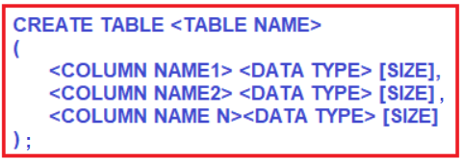

##### ****Example:****

Open SQL Plus editor and then type the username and password

create the Employee table in the Oracle database by using the following CREATE DDL command.

**CREATE** **TABLE** Employee

(

Id **INT**,

Name **CHAR**(100),

Salary **NUMBER**(8, 2)

);

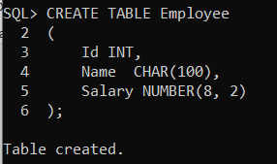

You can see the “Table created” message and that means the Employee table is created successfully.

##### ****How to view the list of tables in the oracle database?****

To view the list of tables in the Oracle database, we need to use the following syntax.

**SELECT * FROM TAB;**

Here, TAB is a pre-defined / system-defined table that shows the list of tables in a database.. Employee table is created.

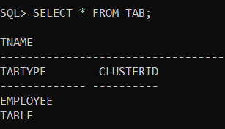

##### ****How to view the structure of a table in the oracle database?****

To view the structure of a table in the Oracle database, we need to use the following syntax.

**Syntax: DESC <TABLE NAME>;** (Desc = Describe)

**Example: DESC EMPLOYEE;**

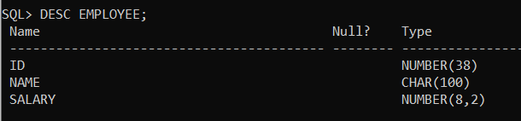

##### ****Rules for creating a table in Oracle:****

1. The Table name must begin with a letter A-Z or a-z
2. The Table name can contain numbers and underscores
3. The name of the table can be in UPPER or lower case
4. The maximum length of the table name can be 30 characters
5. We cannot use the same name of another existing object in our schema
6. The table name must not be a SQL reserved word.
7. Don’t provide space in the table name. If you want to provide space in a table name then you can use the underscore symbol.
8. A table should contain a minimum of 1 column and a maximum of 1000 columns.

##### ****ALTER DDL Command in Oracle:****

This command is used to change or modify the structure of a database object i.e. Table, Views, Stored Procedures, Stored Functions, Triggers, etc

To change/modify the structure of a table, we can use the following sub-commands of Alter Data Definition Language (DDL) Command in Oracle.

1. **ALTER – MODIFY**
2. **ALTER – ADD**
3. **ALTER – RENAME**
4. **ALTER – DROP**

##### ****ALTER – MODIFY DDL Command in Oracle:****

This command in the Oracle database is used to change a data type from an old data type to a new data type and also to change the size of the data type of a column

**ALTER TABLE <TABLE NAME> MODIFY <COLUMN NAME> <NEW DATATYPE> [NEW SIZE];**

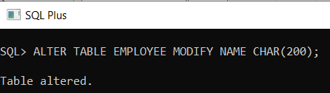

Now, if you verify the structure of the table using **DESC EMPLOYEE;**command, you will see that the Name column length is changed to 200 from 100

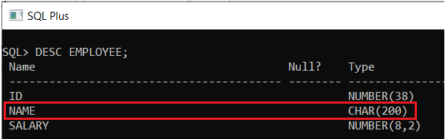

##### ****Example: Changing the data type of an existing column****

##### **ALTER TABLE EMPLOYEE MODIFY NAME VARCHAR2(200);**

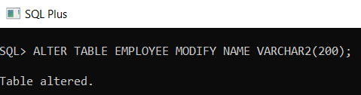

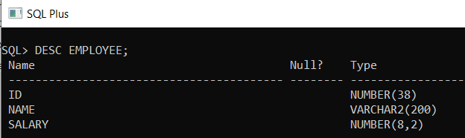

##### ****ALTER – ADD DDL Command in Oracle:****

If you want to add a new column to an existing table in the Oracle database, then you need to use the ALTER ADD DDL Command. The syntax to use the ALTER ADD DDL command in Oracle is given below.

**ALTER TABLE <TABLE NAME> ADD <NEW COLUMN NAME> <DATATYPE>[SIZE];**

**ALTER TABLE EMPLOYEE ADD ADDRESS VARCHAR2(100);**

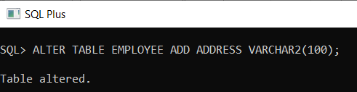

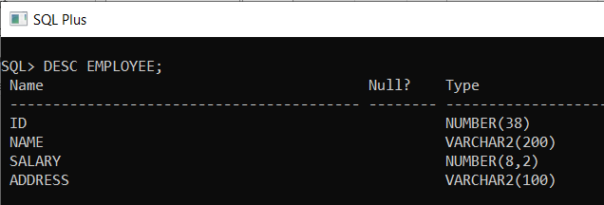

##### ****ALTER – RENAME DDL Command in Oracle:****

Theis ALTER – RENAME DDL Command in Oracle is used to change the column name in a table.

**ALTER TABLE <TABLE NAME> RENAME <COLUMN> <OLD COLUMN NAME> TO <NEW COLUMN NAME>;**

**ALTER TABLE EMPLOYEE RENAME COLUMN ADDRESS TO EMPADDREES;**

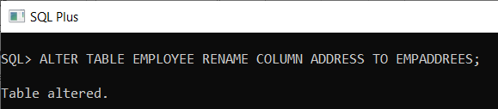

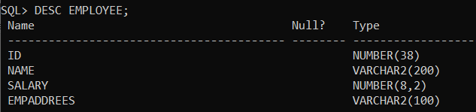

##### ****ALTER – DROP DDL Command in Oracle:****

If you want to delete or drop a column from an existing table, then you need to use the ALTER DROP DDL Command in Oracle.

**ALTER TABLE <TABLE NAME> DROP <COLUMN> <COLUMN NAME>;**

**ALTER TABLE EMPLOYEE DROP COLUMN EMPADDREES;**

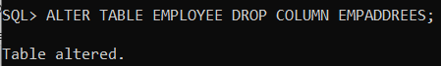

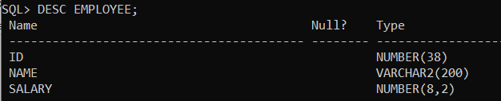

##### ****RENAME DDL Command in Oracle:****

If you want to change the table name then you need to use the RENAME DDL Command in Oracle.

Syntax:

**RENAME <OLD TABLE NAME> TO <NEW TABLE NAME>;**

**RENAME EMPLOYEE TO EMPLOYEEDETAILS;**

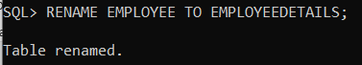

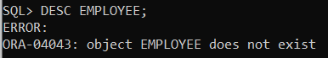

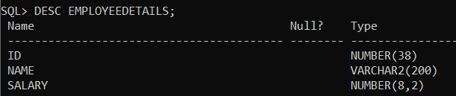

rename the table back to EMPLOYEE by executing the below RENAME statement.

**RENAME EMPLOYEEDETAILS TO EMPLOYEE;**

##### ****TRUNCATE DDL Command in Oracle:****

If you want to delete all the records or rows from a table without any condition, then you need to use the Truncate DDL command in Oracle. So, using this TRUNCATE DDL command you cannot delete specific records from the table because this command does not support the “WHERE” clause.

**TRUNCATE TABLE <TABLE NAME>;**

**TRUNCATE TABLE EMPLOYEE;**

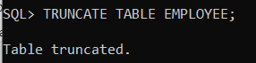

**Points to Remember while working with TRUNCATE Command:**

1. It is used to delete all rows from a table at a time.
2. It is used for deleting rows but not columns.
3. Rows are deleted permanently.
4. Cannot delete a specific row from a table.
5. It is not supporting the “where” condition.
6. The truncate command will delete rows but not the structure of the table.

##### ****DROP DDL Command in Oracle:****

If you want to delete the table (rows & columns) from the database, then you need to use the DROP DDL command in oracle. The syntax to use the DROP command is given below.

**Syntax :**

**DROP TABLE <TABLE NAME>;**

**DROP TABLE EMPLOYEE;**

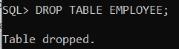

**Note:**  Before oracle10g enterprise edition when we drop a table from the database, the table is permanently dropped. But, from oracle 10g enterprise edition once we drop a table from the database then it will drop temporarily. And the user has a chance to restore the dropped table again into the database by using the commands,

1. Recyclebin
2. Flashback
3. Purge

##### ****RECYCLEBIN Command in Oracle:****

It is a system-defined table that is used for storing the information about the dropped tables. It is similar to Windows Recyclebin. To view the structure of recycle bin,

Syntax :

DESC RECYCLEBIN;

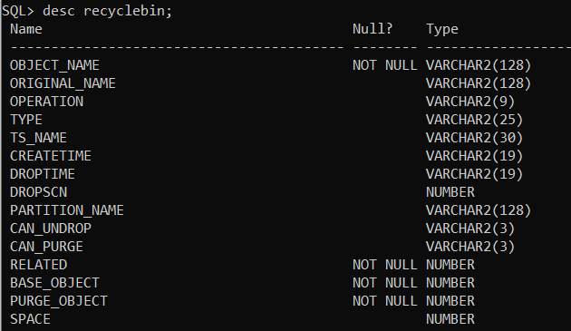

##### ****How to view dropped tables in recycle bin?****

Syntax :

SELECT OBJECT_NAME,ORIGINAL_NAME FROM RECYCLEBIN;

##### ****FLASHBACK Command in Oracle:****

The Flashback command is used to restore the dropped table from recycle bin to the database.

Syntax :

FLASHBACK TABLE TABLENAME TO BEFORE DROP;

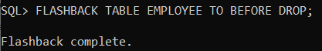

##### ****PURGE Command in Oracle:****

This DDL command is used to drop a table permanently i.e. it will drop a specific table from recycle bin permanently

Syntax :

PURGE TABLE TABLENAME;

Once you delete the table from the recycle bin then you cannot restore the table from the recycle bin into the database by executing the below Flashback command.

##### **to drop all tables from recycle bin permanently in Oracle:**

##### **syntax :**

##### **PURGE RECYCLEBIN;**

##### ****to drop a table from the database permanently****

##### **syntax:**

##### **DROP TABLE TABLENAME PURGE;**

##### **NOTE : under system user recycle bin feature is not available , and using drop command will lead to permenant deletions. So better create a new user and practice with that account .**